Relevance of the Problem of Information Security
Objective: To introduce the fundamental concepts of information security (IS), define its main components (availability, integrity, confidentiality), identify key tasks in this field, and explain the various subject directions of information protection (e.g., state, commercial, and professional secrets).
Main questions:
- The concept of information security.
- The main components of information security.
- Tasks in the field of information security.
- Subject directions of information protection.
Brief content: This lecture introduces the core concept of information security, defining it as the protection of information and its supporting infrastructure from influences that could cause unacceptable damage. It distinguishes this from the narrower "computer security," noting that IS is a broader concept where the weakest link is often the human element, not just the technology. The fundamental goals of IS are established as the "CIA Triad": Confidentiality (protection from unauthorized access), Integrity (maintaining relevance, consistency, and accuracy, with both static and dynamic forms), and Availability (ensuring access to services in an acceptable time). The lecture also outlines the main categories of information that require legal protection, including state, commercial, bank, professional, and official secrets.
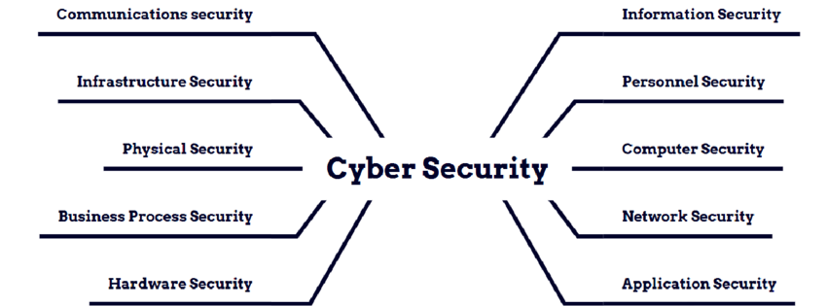
Picture.1-The Domains of Cyber Security
Definitions and Explanations:
Brief content: This lecture introduces the core concept of information security, defining it as the protection of information and its supporting infrastructure from influences that could cause unacceptable damage. It distinguishes this from the narrower "computer security," indicating that IS is a bigger concept where the weakest link is often the human element, not just the technology. The fundamental goals of IS are established as the "CIA Triad": Confidentiality- protection from unauthorized access; Integrity-maintenance of relevance, consistency, and accuracy, including both static and dynamic forms; and Availability-ensuring access to services in an acceptable time. Categories of information requiring legal protection, such as state, commercial, bank, professional, and official secrets, are identified.
IS vs. Computer Security: The term "computer security" is considered too narrow and insufficient. Information security is a fundamentally broader concept because the security of data is determined by the totality of all its components. The weakest link is often not the technology but the human element (users, administrators, service personnel). Security depends on factors far beyond the computer itself.
Supporting Infrastructure: This refers to all components and systems necessary for the information system to perform its prescribed functions. This infrastructure has independent value but is considered here only as it affects the IS. It includes systems like electricity, water and heat supply, air conditioners, communications, and, of course, the maintenance personnel who operate it all. A failure in any of these can lead to a failure in information security (e.g., an outage).
Unacceptable Damage: The goal of information security is not to protect against all possible damage, as this is economically unfeasible. Rather, it is to reduce the size of the damage to acceptable values. One must put up with some risks and defend only against what cannot be reconciled with. While this threshold is often financial (monetary expression), "unacceptable damage" can also refer to harm to human health or the environment.
The Main Components of Information Security (The "CIA Triad"): This is a model used to categorize the interests of subjects associated with information systems.
Availability: This is the opportunity to get the required information service in an acceptable time. The leading role of availability is especially pronounced in various control systems (e.g., production, transport), but its loss is also severe in services used by many people, such as the sale of rail/air tickets or banking services.
Integrity: This implies the relevance, consistency, and accuracy of the information, ensuring it exactly corresponds to source documents and is protected from unauthorized modification or destruction. This has two forms:
Static Integrity: The immutability of information objects (e.g., protecting a saved file from changes).
Dynamic Integrity: The correct execution of complex actions or transactions (e.g., ensuring a financial transfer is processed correctly without duplication or loss).
Confidentiality: This is the protection against unauthorized access to information. Even in open organizations like educational institutions, some information is confidential (e.g., employee salary information, user passwords).
Subject Directions are the types of secrets for which protection of information may be considered, and each has a different scope and purpose.
State Secret: This is high-level information classified by the government for national security reasons. It would cause exceptionally grave damage to the nation's safety, foreign policy, and strategic interests if disseminated without authorization.
Examples include military deployment plans, specifications of new weapon systems, identities of intelligence agents, details of sensitive foreign policy negotiations, or codes used for secure government communication.
Commercial Secret: This is any information which gives a business an edge over its competitors, and this advantage comes from the fact that it is not generally known to the public or to rivals. Its value directly stems from its secrecy; its protection aims precisely at securing profits and rewarding innovation.
Examples include the formula for a particular soft drink, an algorithm for proprietary software, an efficient and unique manufacturing process, a list of customer contacts, or even the strategic marketing plan of a company.
Bank secrecy is a legal and ethical commitment by banks and all other financial institutions not to disclose their clients' financial information to any third party without clients' consent, except in cases legally provided for, like a court order.
Examples: A history of a customer's account balance, their transactions and transfers, detailed information on a loan or whether the customer has one, or any personal identifying information the customer may have supplied to the bank when opening the account.
Professional Secrecy: This is a broad category, where, in the course of performing his or her functions, certain information has been entrusted to the professional. The professional is both legally and ethically bound not to disclose such information; disclosure would be injurious to the client's rights, reputation, or interests.
Examples:
Medical Confidentiality: The physician's knowledge of the diagnosis, treatment, or health status of a patient.
Advocacy Secret ( Attorney-Client Privilege ): Information provided by a client to his attorney in connection with the legal representation.
Notarial Secret: Information disclosed to a notary in the course of performing acts such as preparing a will or property deeds.
Secrecy of Confession: Information given by a person to a priest or religious minister in confession.
Secrecy of Communication: The contents that are protected by law from interceptions include letters, telephone calls, and emails.
Official Secret (or Service Secret): This refers to confidential information used by state and local government bodies. It is usually less critical than a 'State Secret' but is still restricted in order not to hamper the due working of the government, administrative processes, or the privacy of citizens dealing with it.
Examples include: Internal government deliberations not yet made public, draft versions of pending legislation, non-public details of a an administrative investigation, or personal data of citizens held in a government database (e.g., tax records, property ownership).
Practical Relevance and Key Takeaways:
This introductory lecture sets up the "why" of information security. The key point is that security is not strictly a technological problem; instead, it is a business, human, and organizational issue. This lecture provides the basis for everything that follows by outlining the basic principles:
Security is holistic, not just technical. The difference between "Information Security" and "Computer Security" actually makes an important conceptual difference: one can't shield the network if an employee writes their password on a sticky note (the "human element"), or if power outage (the "supporting infrastructure") takes the system down.
The "CIA Triad" as a balancing act: the Availability, Integrity, and Confidentiality model is the essential framework for balancing security priorities. Different organizations will prioritize these differently. For example, a bank may prioritize Integrity-preventing unauthorized money transfers-above all else, while a military system would focus most on Confidentiality-preventing secrets from being read.
Protection is about risk and value. The concepts of "Unacceptable Damage" and "Subject Directions (Secrets)" are linked. Security isn't about reaching absolute, 100% perfection. It is about determining what is most valuable-a "State Secret" is clearly quite more valuable than public information-and proportionally implementing enough resource measures to protect it from the most probable perils, reducing the risk to an "acceptable level."

5. Control questions:
- What is information security, what are its aspects?
- What relates to the supporting infrastructure of an information system?
- List the tasks of information security.
- What is a state secret?
- What is a trade secret?
- What is a professional secret?
- What is an official secret?
- What are the main protected objects?
6. Recommended literature:
- Partyka T.L., Popov I.I. Information Security. Textbook for students of vocational schools. M.: FORUM: INFRAM, 2002.
- Galatenko V.A. The basics of information security. Lecture course. - M, 2008.

